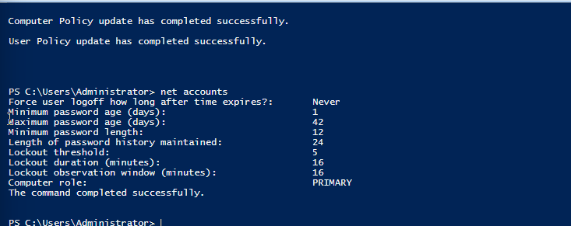
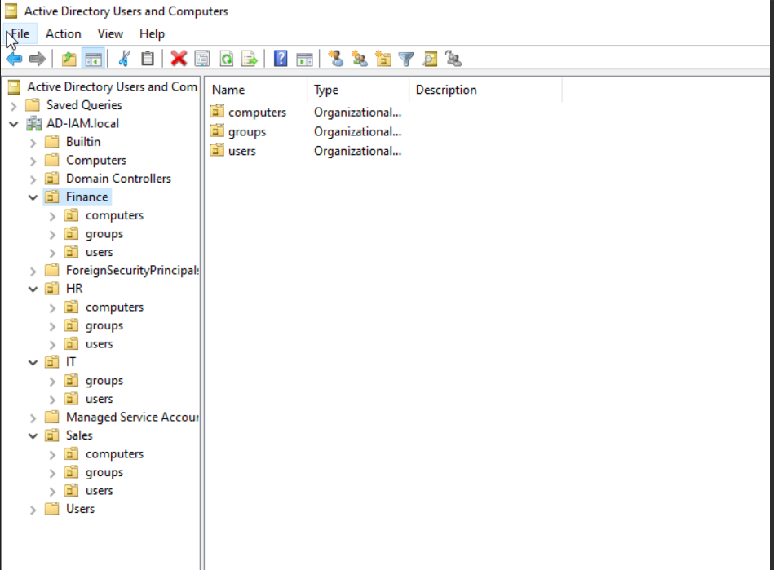

The Active Directory OU structure is organized around the organization's major departments: IT, Finance, HR, and Sales. Each department contains separate Users, Groups, and Computers sub-OUs to provide clear identity and resource organization. Separating users and computers makes it easier to apply different Group Policies to users and devices, while dedicated Groups OUs provide a logical location for security groups used for role-based access control (RBAC). The departmental structure also supports future administrative delegation, allowing administrators to manage specific departments without affecting the entire domain. This design provides a scalable foundation for identity lifecycle management, GPO scoping, access governance, and RBAC in later IAM modules.
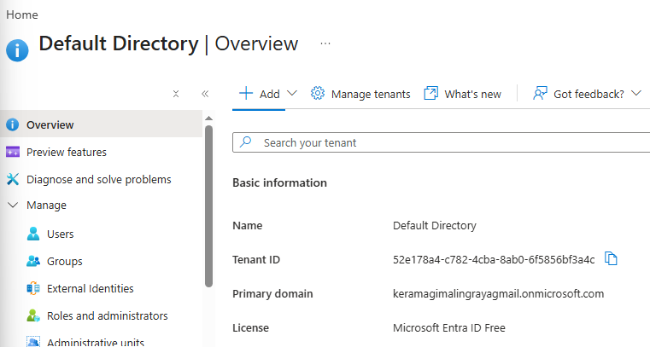
Connecting Microsoft entra ID to Active Directory
